LONDON CITY AIRPORT GROWTH PROPOSALS

A summary of their potential impacts on noise, climate, air pollution and surface transport

The details of the plans can be found on London City’s website at https://consultation.londoncityairport.com/. The proposals are out for consultation until 9th September. Whatever plans the airport decides to take forward will need to go before Newham Council, the planning authority.

In summary, these are the key proposals:

- an increase in annual passenger limit from 6.5million to 9million;

- getting rid of the current curfew on flights (12.30pm Saturday – 12.30pm Sunday) to allow flying on a Saturday afternoon and evening - there will be no change to the current operating hours on Sunday, with no flights before 12.30pm;

- An increase in the number of flights permitted between 06:30 and 06:59, from 6 to 12

- ‘more flexibility’ for delayed departures and arrivals in the last half hour of operations each day (10pm – 10.30pm) – they are currently limited to 400 per year;

- only the ‘cleaner, quieter’ planes will be allowed during the additional hours of operation – London City believes this will act as an incentive for airlines to renew their fleet so these aircraft become the norm at all times. These planes are larger which allows London City to seek to increase annual passenger numbers while not exceeding its annual permitted cap on flight numbers.

What is not changing:

- The 8 hour night ban will remain (10.30pm – 6.30am)

- The current annual cap of 111,000 flights will remain – London City seems to have dropped, certainly for now, the proposal in its Masterplan to seek to increase it to 151,000.

- No increase at parking at the airport.

However, if the proposals go ahead, London City expects flight numbers to be 110,000 per year by 2031, very close to the legal limit of 111,000. Will the airport then press to raise the annual cap?

If the current proposals are not agreed, annual flights numbers in 2031 are predicted to be a little over 80,000, the sort of level they were at pre-pandemic.
A parallel process is taking place where London City is looking to reorganize its flight paths – as are all UK airports. In 2016 the airport concentrated all its flight paths. The new proposals are expected to include alternation of flight paths in order to provide respite for communities, where possible. Also, at present London City aircraft are flying lower than they need to both on arrival and departure because of the Heathrow aircraft above them. Any new arrangement needs to separate the two in order to raise the height of the City flights. City will not consult on any flight path changes until end 2023/early 2024, with the new flight paths expected to be in place by 2027/8. It would have made much more sense for the growth proposals and the flight path changes to have been coordinated as the flight path changes, done well, could allow planes to fly higher and for routes to be alternated to give some relief to many communities.

THE NEW PLANE
The selling point of London City’s proposals is the introduction of the new Embraer E195-E2

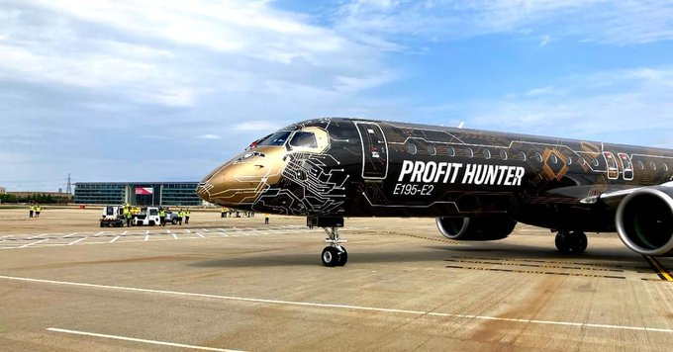

The Embraer visiting London City during the Farnborough Airshow

London City is banking on the fact that by just allowing these planes to be used during the extended hours this will act as an incentive for airlines to renew their fleet so these aircraft become the norm at all or most times. (Airlines will have to re-fleet anyway over time; meaning the new planes will come in without expansion, but more slowly). Based on this, London City has made predictions about the future impact on noise, climate, air pollution and surface transport. We look at each of these in turn.

The information below is taken from London City’s Initial Environmental Report: https://consultation.londoncityairport.com/key-documents/

THE IMPACT ON NOISE

2025DM 2025DC 2027DM 2027DC 2031DM 2031DC
51 | 201,000 | 198,650 | 202,800 | 151,000 | 156,050 | 161,250
54 | 114,100 | 111,550 | 115,400 | 81,000 | 82,750 | 88,200
57 | 51,450 | 49,450 | 52,000 | 34,700 | 36,500 | 40,950
60 | 18,450 | 18,300 | 18,750 | 13,300 | 13,900 | 15,350
63 | 5,050 | 4,700 | 5,250 | 2,150 | 2,300 | 2,650
66 | 800 | 650 | 800 | 650 | 650 | 650

This is Table 6 in London City’s Initial Environmental Report. The first column is the noise levels in decibels as averaged out over a 16 hour day. It shows how many people live will live within each noise contour. The DM column is what is predicted to happen if the airport does not get consent for its proposals. The DC column is assuming consent, what City calls the Development Case. Many residents argue that they do not hear ‘average’ noise. A number of airports, such as Heathrow, use additional metrics such as the ‘N’ metric which indicates the number of planes which fly overhead above a chosen decibel level.

Here’s how the airport sums it up:

In summary, the noise contour areas are forecast to reduce from 2025 onwards in Development Case due to the influence of airlines re-fleeting with quieter new generation aircraft such as new Embraer E195-E2. The noise contour areas are then forecast to increase between 2027 and 2031 but will remain below the 2025 areas. Without the proposed amendments, the area of the noise contours will reduce more slowly, due to the slower transition to new generation aircraft, albeit by 2031 the noise contours will be slightly smaller overall because of the curtailed number of aircraft movements at this time.

Read the small print!

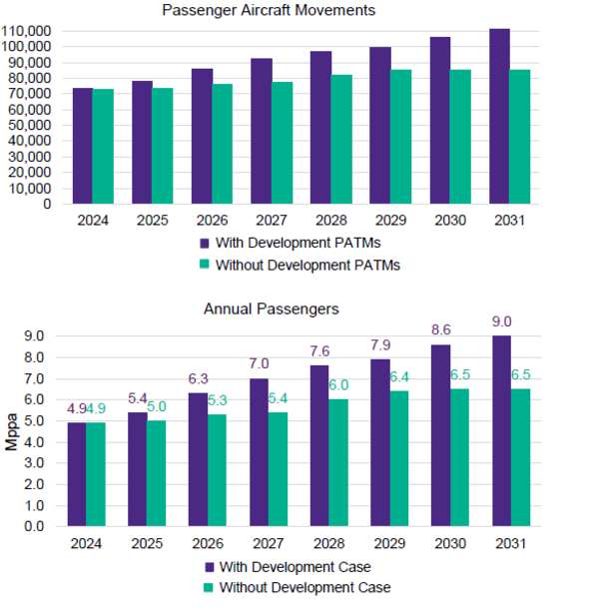
London City is going big on highlighting the noise benefits of the Embraer E195-E2. It has previously talked of a 6 decibel reduction in noise per plane. That would be noticeable but it only applies to departing planes and only within about 4 miles of the airport. For everybody else, City’s noise consultants are clear the reduction is likely to be no more than 2-3 decibels. That would be barely noticeable. The Civil Aviation Authority says that a change of 3dB is just noticeable to the human ear. Even that small benefit would be off-set by the increased number of planes there will be in 10 years time if the growth proposals are approved.

Numbers Count!

In the year before Covid there were around 83,000 aircraft using the airport each year (Passenger Aircraft Movements). If London City’s growth proposals go ahead, this will rise to 110,000 each year. That is 30,000 more planes on the concentrated flight paths over the same communities each year. For most of these communities, each plane will not sound any quieter than those they will replace. Increasing the number of flights simply increases the disturbance.

THE IMPACT ON CLIMATE
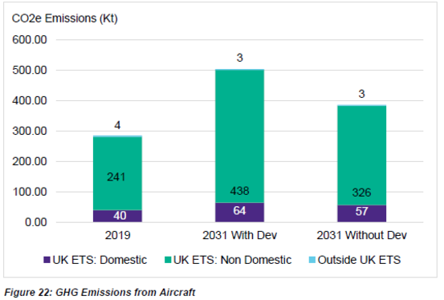

Here’s how the airport sums it up:

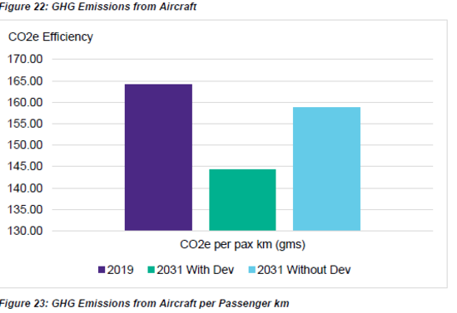
Figure 22 shows that aircraft GHG emissions in 2031 will increase from the 2019 baseline in both the with (DC) and without (DM) development scenarios. However, the increase with the development is somewhat higher during this assessment timeframe as a result of a greater number of movements by 2031 and a shift to new generation aircraft which, whilst more fuel efficient, also have a longer destination range.

THE IMPACT ON AIR POLLUTION

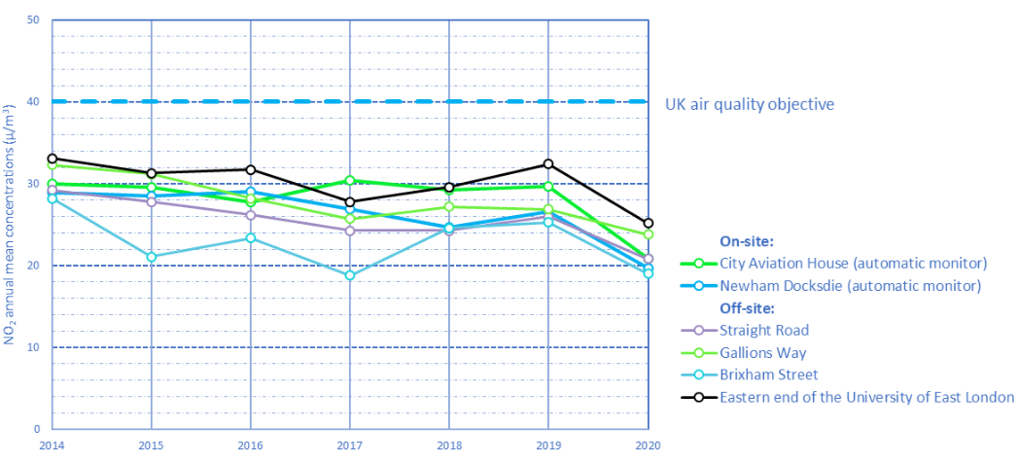

Here’s how the airport sums it up:

As described in the Baseline section above, concentrations of the principal pollutants of concern (nitrogen dioxide, PM10 and PM2.5) are currently well below the air quality objectives in the vicinity of the airport, and at locations in close proximity to both Hartmann Road East and Connaught Road. A detailed air quality assessment was carried out to support the 2020 Master Plan. This was based on an assumption of 151,000 ATMs [air traffic movements] by the mid to late 2030s and, consequently, much higher traffic flows on the local road network than would occur with the current cap of 111,000 ATMs which is predicted to be reached by 2031 with the current proposals. Even with the higher assumption of 151,000 ATMs, the study concluded that concentrations of all pollutants would be well below the objectives. Based on the current pollutant concentrations and the predicted changes to traffic flows, it can be reasonably concluded that there will be no exceedances of the objectives with 9.0 mppa in 2031.

THE IMPACT ON SURFACE TRANSPORT

Here’s how the airport sums it up:
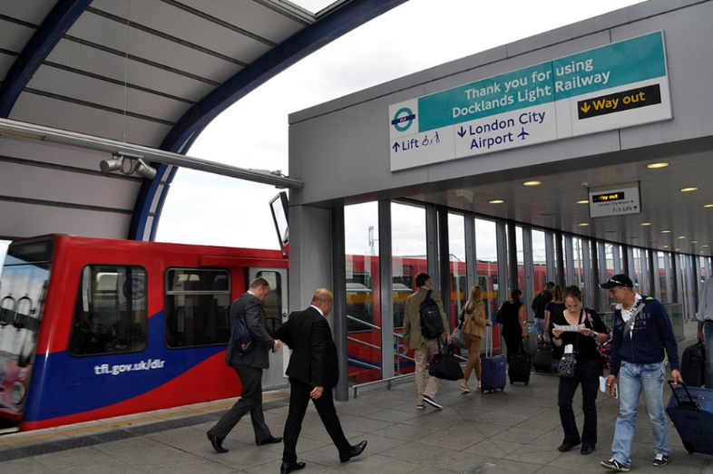
London City Airport is the UK’s best performing airport for sustainable transport use. [It] has the highest public transport use amongst passengers of any UK airport, with only 9% arriving by private car. The current Airport Surface Access Strategy sets ambitious short-term targets to achieve 75% of passenger journeys by public and other sustainable transport modes and fewer than 40% of staff travelling by single occupancy car by 2025. The airport has set the target of increasing the proportion of passengers travelling to/from the airport by sustainable modes (as defined in the National Planning Policy Framework) to 80% by the time 9m passengers per annum is achieved in the early 2030s.

IN SUMMARY

The proposed growth plans, relying on the uptake of the new aircraft:

- Will not result in air pollution exceeding the target level

- Will not hinder plans to enable 80% of passengers to use sustainable modes of surface transport

- Will increase climate change emissions

- Will reduce the overall noise footprint but that will not reduce annoyance for most people overflown as there will be more aircraft flying longer hours. The result will be an increase in noise problems for many communities. This is particularly the case because the growth proposals are planned to be introduced several years before any plans to alter the flight paths which may increase the height of the aircraft over many areas and introduce the principle of alternation to provide some respite.

Written by John Stewart
Chair HACAN East

www.hacaneast.org.uk; twitter @HACANEast

